**Concept of a thirst Person Survival Game**

**1. General Description for a Player**

**Title: Lost Island Survival**

In *Lost Island Survival*, you play as a survivor of a plane crash who wakes up stranded on a mysterious island. Your mission is to survive the wilderness, search for your missing brother, and escape the island. The island is teeming with natural resources like bushes for berries, trees for wood, and animals to hunt—but survival won't be easy. You'll have to eat and drink, all while exploring the island.

From gathering wood to craft a campfire, to hunting animals for food, every decision you make impacts your chances of survival. Drinking water from natural sources and cooking raw food over a fireplace will help keep you alive.

Your ultimate goal is to find clues about where your brother is and eventually reunite with her.

**Core Features:**

* **Survival Mechanics**: Track your health, hunger, and thirst bars to stay alive. (required)
* **Resource Gathering**: Forage for berries (required), hunt animals (optional), and chop wood (required) to survive.
* **Crafting**: Create a fireplace to cook food. (required)
* **Exploration**: Explore the island (required), uncover hidden areas (required), and gather clues about your brother (optional).
* **Wildlife**: Animals roam the island. (optional)

**2. Technical Description for a Developer**

**Platform**: PC (Windows)  
**Engine**: Unity  
**Language**: C#

**Core Gameplay Mechanics:**

1. **Player Movement**:
   * Thirst-person character movement, including walking with W-A-S-D, running with W + shift, and jumping with space. (required)
   * Camera is thirst person. (required)
   * Unity's **Starter Assets - Thirst Person Character Controller** can be used for this.
2. **Survival Stats**:
   * Stats include health, hunger, and thirst, which decrease over time. Hunger and thirst rates are affected by player actions such as gathering food or drinking water. (required)
   * Health decreases if hunger or thirst fall to zero, and death occurs when health reaches zero. (required)

Ein Bild, das Text, Screenshot, Schrift enthält.

Here is shown how the Food and Water Bars are decreasing over time.

1. **Resource Gathering**:
   * Interactable objects like berry bushes for food (required), trees for wood (required), and animals for hunting (optional).
   * Simple OnTriggerEnter scripts detect player interaction when they are within range and press “E”, awarding the corresponding resources. (required)
   * Food items provide hunger points (required), water sources restore thirst (required), and wood is used for crafting. (required)
2. **Crafting System**:
   * A basic inventory system with 5 slots that tracks gathered resources. (required)
   * The crafting recipe of a campfire (3 units of wood) to craft a campfire with the key “c”. (required)
   * The player can place a fireplace object to cook food. (required)

Ein Bild, das Text, Screenshot, Software, Display enthält.

Here the logic for adding an Item to the Inventory and removing one from the Inventory, in this case eating a Berry, is shown.

Ein Bild, das Text, Screenshot, Software enthält.

That’s the logic of pacing a Campfire.

1. **Wildlife and AI**:
   * Simple AI for animals: animals roam randomly and can be hunted by the player. (optional)
   * Upon hunting, animals drop resources like raw meat, which can be cooked or eaten. (optional)
2. **User Interface**:
   * Health, hunger, and thirst bars are displayed on the screen at all times. (required)
   * A basic inventory UI with 5 slots showing gathered resources and crafted items. (required)
   * Interaction prompts appear when the player is near gatherable resources.

**Graphics and Assets**:

* Terrain created using Unity's **Terrain Editor**. (required)
* Free assets for trees (required), bushes (required), rocks (required), animals (optional), and a fireplace (required) from the Unity Asset Store.

**Stretch Goals** (Optional):

* Adding more complex AI behaviors for animals.
* More advanced crafting options (e.g., creating weapons, shelter).
* Implementing different weather conditions (rain, storm, etc.).
* Tips for the player where the brother could be

**3. Visuals (Player View, Startup UI, In-Game UI, Map)**

**Visual 1: Player View**  
The player is in thirst-person view, exploring a tropical island. In the distance, a few mountains are visible. On the ground there are bushes and trees that can be interacted with.

Ein Bild, das Zeichnung, Kinderkunst, Clipart, Darstellung enthält.

Ein Bild, das Himmel, Weinberg, Pflanze, draußen enthält.

**Visual 2: Startup UI**  
On the startup screen, you see the game’s title *Lost Island Survival*, with the options:

* **Start Game**
* **Options**
* **Quit Game**

The background is the Player View from the beginning.

Ein Bild, das Text, Clipart, Grafikdesign, Grafiken enthält.

Ein Bild, das Screenshot, Pflanze, Baum enthält.

**Visual 3: In-Game UI**  
The in-game UI consists of:

* **Health Bar**: Top left corner.
* **Hunger and Thirst Bars**: Top right corner.
* **Crafting Inventory**: At the Bottom there are 5 Inventory Slots that can be accessed with the Keys 1-5.
* **Interaction Prompt**: When the player is near a bush or animal, a prompt appears (e.g., “Press E to Gather”).

Ein Bild, das Karte enthält.

Ein Bild, das Screenshot, Pflanze, Baum, Weinberg enthält.

**Visual 4: Map of the Island**  
A basic hand-drawn-style map of the island. The map includes key areas such as:

* **Start** (where the player starts).
* **Beach**
* **River** (where the player can drink water).
* **Mountain Area** (where the player might find clues about the brother).



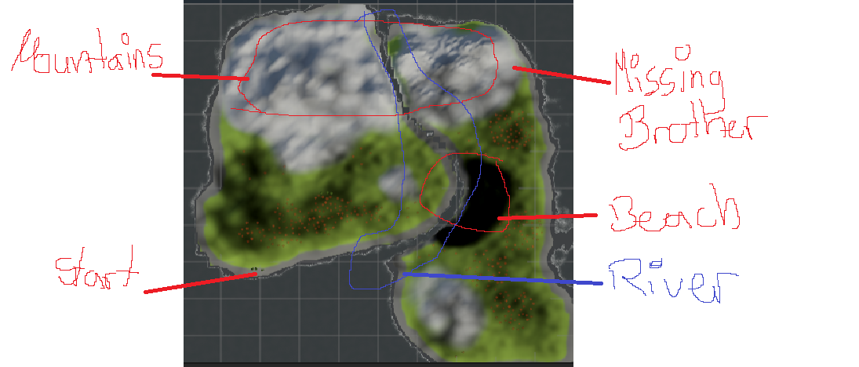

**4. Detailed List of Game Modules**

**1. Player Controller (Thirst-Person)**

* Basic movement (walking, running, jumping). (required)
* Move freely. (required)
* Camera is what the player can see. (required)
* Slow based. (required)

**2. Survival Stats (Health, Hunger, Thirst)**

* Hunger and thirst decrease over time, health decreases when food or water is at zero. (required)
* The player must gather food and water to replenish hunger and thirst. (required)

**3. Resource Gathering**

* Interactable objects like bushes for berries and trees for wood. (required)
* Basic hunting mechanics for animals (optional).
* Gathering items triggers stat recovery or provides crafting materials. (optional)

**4. Crafting System**

* Crafting a fireplace using 3 gathered wood with the Key “c”. (required)

**5. Basic Cooking Mechanic**

* Ability to cook raw meat/berrys on the fireplace. (required)
* Cooking provides more hunger points than eating raw food. (required)

**6. Wildlife and Simple AI**

* Animals roam randomly and can be hunted. (optional)
* Hunting provides meat and other resources. (optional)

**7. Day-Night Cycle**

* A simple time-of-day system that affects the lighting of the game environment. (optional)
* This adds immersion and a sense of urgency for the player to find resources before nightfall. (optional)

**8. Terrain and Environment**

* Basic island layout with terrain editor (forest, lake, beach, etc.). (required)
* Trees, bushes, rocks, and other natural objects for aesthetic and interaction. (required)
* The Player drowns in the water because he can’t swim. (required)
* Tips about the whereabouts of the brother. (optional)

**9. Inventory System**

* Keep track of collected resources. (required)
* Resources are consumed or used for crafting. (required)

**10. Advanced Crafting (Tools, Weapons, Shelter)**

* Expand crafting to include more items like tools (axes for chopping wood) and shelter. (optional)
* Shelter provides protection at night or during weather events (stretch goal). (optional)

5. Development

1. Technical Descriptions and Development Challenges

Survival Mechanic Scripting:

* The survival stats (health, hunger, thirst) decrease at set intervals, with each stat tied to actions like gathering food or finding water.
* Challenge: Handling the interactions smoothly required debugging to ensure stats correctly update when resources are gathered.

Resource Gathering:

* Gathering is implemented through OnTriggerEnter mechanics. The player’s proximity to objects like bushes or trees triggers an interaction prompt, awarding resources upon confirmation.
* Challenge: Debugging the berryPrefab error involved confirming object references and ensuring resources were properly assigned.

Crafting System:

* Crafting recipes, such as using wood to create a fireplace, are implemented with a simple UI displaying available resources.
* Challenge: Developing a resource-tracking inventory that connects to the crafting system required adjustments to handle item removal when crafting occurs.

UI Development:

* Key UI elements include health, hunger, and thirst bars and the inventory system. UI design focuses on clarity and ease of access.
* Challenge: Ensuring interaction prompts and the crafting inventory were intuitive for users required iteration on UI layout and functionality.

2. Time Management

* Phase 1: Environment Design (2 weeks) – Setting up terrain and adding assets like trees, bushes, and rocks.
* Phase 2: UI and Inventory (2 weeks) – Implementing health, hunger, and thirst bars, as well as inventory UI.
* Phase 3: Resource Gathering and Crafting (3 weeks) – Scripting gatherable resources, basic inventory functionality, and crafting.
* Phase 4: Final Debugging and Testing (2 weeks) – Resolving errors, ensuring functionality, and testing gameplay.

3. References

* Unity Asset Store: Free assets for trees, rocks, and animals were used.
* Unity Documentation: Utilized official documentation for scripting OnTriggerEnter interactions and the Unity Terrain Editor.
* Unity Starter Assets: Thirst-person character controller to manage player movement and interactions.